**Module – 1 SE – Overview of IT Industry**

**Que.1 What is software? What is software engineering?**

**Ans.1: Software** is a program or set of programs containing instructions that provide the desired functionality. Engineering is the process of designing and building something that serves a particular purpose and finds a cost-effective solution to problems.

**Software Engineering** is the process of designing, developing, testing, and maintaining software. It is a systematic and disciplined approach to software development that aims to create high-quality, reliable, and maintainable software.

**Que.2 Explain types of software**

**Ans.2 Types of Software:** It is a collection of data that is given to the computer to complete a particular task. There are two types of Software:

* 1. System Software
     + Operating system
     + Language processor
     + Device Driver
  2. Application Software
     + General Purpose software
     + Customize Software
     + Utility Software

**System Software:** software that directly operates the [computer hardware](https://www.geeksforgeeks.org/computer-hardware/) and provides the basic functionality to the users as well as to the other software to operate smoothly. It is like an interface between hardware and user applications, it helps them to communicate with each other because hardware understands machine language whereas user applications are work in human-readable languages like English, Hindi, German, etc. so system software converts the human-readable language into machine language.

**Application Software:** application software is designed to perform a specific task for end-users. It is a product or a program that is designed only to fulfill end-users’ requirements. It includes word processors, [spreadsheets](https://www.geeksforgeeks.org/introduction-to-excel-spreadsheet/), database management, inventory, payroll programs, etc.

**Que.3 What is SDLC? Explain each phase of SDLC**

**Ans.3** The Software Development Life Cycle (SDLC) is a process used by [software development](https://www.geeksforgeeks.org/software-development/?ref=lbp) organizations to plan, design, develop, test, deploy, and maintain software applications.

To provide a **structured and organized approach**to software development: The SDLC provides a framework for managing the software development process, which helps to ensure that all necessary steps are taken and that the final product meets the requirements.

The SDLC includes the following phases:

[**Requirements gathering and analysis:**](https://www.geeksforgeeks.org/requirements-gathering-introduction-processes-benefits-and-tools/)This phase involves gathering information about the software requirements from stakeholders, such as customers, end-users, and business analysts.

**Design:** In this phase, the software design is created, which includes the overall architecture of the software, data structures, and interfaces. It has two steps:

* High-level design (HLD): It gives the architecture of software products.
* Low-level design (LLD): It describes how each and every feature in the product should work and every component.

**Implementation or coding:** The design is then implemented in code, usually in several iterations, and this phase is also called as Development. Things you need to know about this phase:

* This is the longest phase in SDLC model.
* This phase consists of Front end + Middleware + Back-end.
* In front-end: Development of coding is done even SEO settings are done.
* In Middleware: They connect both the front end and back end.
* In the back-end: A database is created.

**Testing:** The software is thoroughly tested to ensure that it meets the requirements and works correctly.

**Deployment:** After successful testing, the software is deployed to a production environment and made available to end-users.

**Maintenance:** This phase includes ongoing support, bug fixes, and updates to the software.

**Que.4: What is DFD? Create a DFD diagram on Flipkart ?**

**Ans.4:** DFD stands for Data Flow Diagram.Data Flow Diagrams (DFD) provide a graphical representation of the data flow of a system that can be understood by both technical and non-technical users. The models enable software engineers, customers, and users to work together effectively during the analysis and specification of requirements.

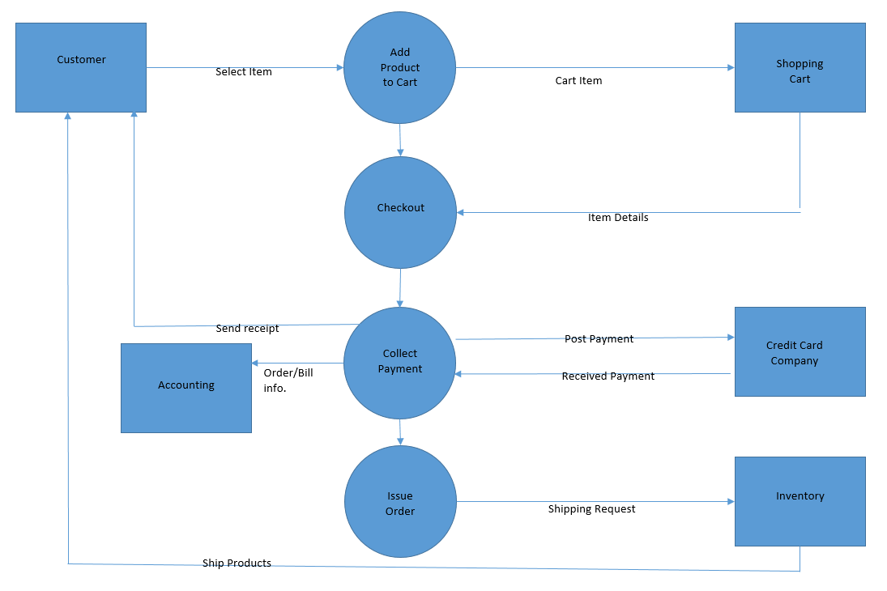

**Que.5 What is Flow chart? Create a flowchart to make addition of two numbers.**

**Ans.5** A flowchart is a type of diagram that represents a workflow or process. A flowchart can also be defined as a diagrammatic representation of an algorithm, a step-by-step approach to solving a task.

**Flow Chart Symbols:**

|  |  |
| --- | --- |
| Terminal/Terminator |  |
| Process |  |
| Decision |  |
| Document |  |
| Data or Input/ Output |  |
| Stored Data |  |
| Flow Arrow |  |
| Comment |  |
| Predefined Process |  |
| On-Page connector |  |
| Off-page connector |  |

**Flowchart to make addition of two numbers:**

Start

Read a, b

C= a +b

Print C

End

**Que.6 What is Use case Diagram? Create a use-case on bill payment on paytm.**

**Ans.6** A Use Case Diagram is a vital tool in system design, it provides a visual representation of how users interact with a system. It serves as a blueprint for understanding the functional requirements of a system from a user’s perspective, aiding in the communication between stakeholders and guiding the development process.

